Regnum Christi Federation
Locality Planning Guidelines

Planning objective: To discern together as a spiritual family the best way forward in living out our common mission to make the Kingdom of Christ present in the locality.
Why bother: Our mission will flourish in localities which live a strong apostolic dynamism and spirit of collaboration. The process of planning together helps build commitment and momentum toward a common and compelling vision, aligns expectations of who is setting out to do what thereby identifying possibilities for synergy and minimizing redundant efforts, and helps to determine and prioritize where people should focus their efforts for the good of the common mission.
Locality Planning according to the Regulations of the Regnum Christi Federation:
43. § 1. The locality plan is the instrument that guides and governs the development of the apostolic life and activity of the Federation.
§ 2. The plan:
1.º illuminates and promotes the personal initiative of the members;
2º guides the programs of the local sections and apostolates, respecting their areas of responsibility;
3.º illuminates the pastoral programs of the educational centers and the community projects of the federated institutions' local communities;
4.º coordinates and integrates what Regnum Christi offers so as to favor the lives of families;
5º is elaborated within the framework of the territorial guidelines, taking into account the pastoral plan of the diocese.
§ 3. Sections, works, apostolates, parishes and communities add to the plan from their specific identity and mission.

Developing a Locality Strategy:
- A locality strategy provides a high-level ‘map’ of how the locality is moving forward as a whole in the common mission of Regnum Christi. It communicates how both the individual and collaborative initiatives of the locality contribute to the overall evangelizing objectives of building the Kingdom.
- A locality strategy:
  - Serves as the basis for the development of more concrete locality, section and Federation apostolate plans.
  - Serves as important input for other RC entities in the locality, primarily addressing the evangelizing and RC collaboration components of their respective plans.
- A strategy is typically developed once every three or so years and reviewed and updated annually.
- The locality strategy document typically communicates the following:
  - Locality evangelization vision and mission
  - Locality evangelization priorities
  - Locality evangelization specific objectives
  - Accountability and communications plan
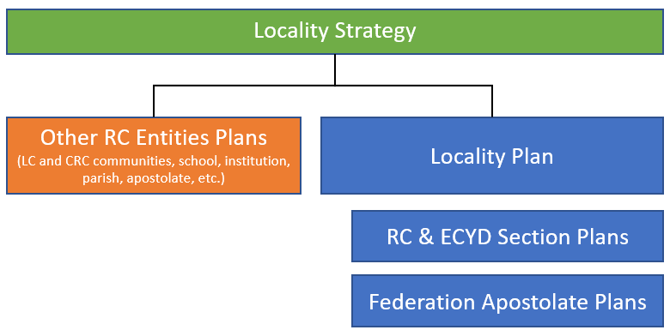
Developing a Locality Plan:
- A locality plan is a one-year ‘action’ plan that sets out concrete steps forward in the strategy for those entities under the direct authority of the RC local director.
- A locality plan document might address the following:
  - Priorities for the Federation considering the locality’s strategic priorities and specific objectives
  - Priority objectives by section
  - Objectives for collaboration across the locality and with the diocese
  - Objectives for locality communications, finances, and administration of the locality
- Given the annual cyclical nature of our evangelizing work, a good practice is to conduct locality planning once a year. Locality plans typically span the school year planning cycle – September through August, or July through June.
- A generic template for documenting a locality plan is available HERE. Localities are free to use and adapt the template to suit their local needs.
- Locality plans are due to the Territorial Directive College in June. The Territorial Directive College reviews these plans to confirm that localities are organized and effective in their efforts to extend the mission and are collaborating in their planning efforts.
- The Territorial Directive College considers locality plans when determining its priorities and allocation of resources to support the localities in their annual August planning session.
Planning Methodology Best Practices for RC Localities
There are many effective planning methodologies to choose from, depending on the needs of the particular locality. This guide does not propose one, but offers some suggestions for you to consider when designing your local planning process.
Pre-Planning Considerations:
- Allow for a lead time to set a date for the planning session.
- Invite the key RC leaders in the locality (section directors, RC apostolate directors, RC institution directors, community superiors/director, etc.) plus others who can provide valuable insight and leadership
- In advance, identify someone to facilitate the meeting (Contact RCD Support for a list of possible facilitators)
- Use a space conducive for your session (enough space to break out in smaller discussions, wall space for flip charts, etc.
- Invite those participating to pray for this meeting in advance and up until this planning session.
- As appropriate, visit with the local ordinary to better understand his diocesan plan and his needs for the evangelization of his people.
Planning Session Ideas:
- On the day of the session, begin perhaps with a Gospel Reflection or short retreat.
- Stand back and look at the locality’s overall mission in light of God’s plan for Regnum Christi:
  - Discuss “the signs of the times” and Regnum Christi’s response in this light
  - Review the past year with an eye to discover what the Holy Spirit has been revealing
- Review and assess the current situation:
  - Have each represented group give a presentation on their contribution to the mission, an assessment of how it is going, and ideas they have for going forward. The beauty of a locality is that the Holy Spirit will be inspiring creative responses from all Regnum Christi members. Develop a ‘map’ of the locality that shows where each RC “community of apostles” is engaged.
  - Reflect upon the overall health and ‘vibrancy’ of the locality’s various apostolic communities (sections, apostolates, LC / CRC community, institution, etc.) and the degree of effective collaboration across these communities.
  - Discuss what each entity in the locality considers success in the mission and look at the current results to see where the Holy Spirit is bringing about fruits from the efforts.
- Look to the future: vision and values
  - When setting a vision for the future, it might be helpful to reflect together on key aspects of our charism, including:
    - “The Principles of Apostolic Action” in the Statutes of the Regnum Christi Federation (SRCF 32-39) to help guide the choice of apostolic activities and the way we carry them out.
    - “A Way of Self-Giving” in the Statutes of the Regnum Christi Federation (SRCF 10) confident that it is the love of Christ that impels us.
- Set up for success
  - Allocate time to agree on concrete next steps so there is clarity on who is accountable for what and how the locality will follow-up on the plan. Agree on a what months of the year the group will “check in” on progress as a whole and if any course corrections/adjustments are needed.
Next Steps after the Locality Strategy and/or Plan is Developed
Locality Strategy
- The RC local director takes a leadership role in consolidating the strategy, submitting it to the Territorial Directive College for approval and communicating it to Regnum Christi members in the locality. Locality strategies can be submitted at any time.
- The RC local director conducts periodic ‘check-in’ meetings as agreed with RC leadership in the locality to share progress and make adjustments as needed.
- The RC local director implements a communication plan to keep stakeholders, including local RC members and the Territorial Directive College, apprised as needed.
Locality Plan
- The RC local director takes a leadership role in consolidating the plan, submitting it to the Territorial Directive College for approval and communicating it to Regnum Christi members in the locality. Locality plans are due June 15 of each year and the corresponding locality budgets in September.
- The RC local director monitors the execution of the plan through regular leadership team meetings.
- The RC local director tasks the section directors and Federation apostolate director to the development of their respective plans.
- The RC local director implements a communication plan to keep stakeholders, including local RC members and the Territorial Directive College, apprised as needed.
Section Plans
- Section directors take the locality strategy and plan and work with their respective section leadership teams to develop concrete plans for the development of their sections.
- Section plans address the following topics as appropriate:
  - Priorities for the section considering the locality plan’s priorities
  - Section life (spiritual life, formation, apostolate, accompaniment, team life)
  - Section leadership
  - Communications
  - Finances and administration
  - Section budget
  - Section calendar
- For support in developing section plans, section directors can access sample plans in the Formation Pathway and contact the RC Life and ECYD Life departments for advice.
- RC section directors are encouraged to review the “Identity and life of the lay members of Regnum Christi” in the Rule of Life for Lay Members (ROL 1-15) to help facilitate section life planning discussions.
- Section directors and federation apostolate directors submit their plans to the RC local director for approval. The RC local director, with the support of the RCD Council, reviews and approves these plans in light of the locality plan.
- The RC local director holds section directors and Federation apostolate directors accountable for the executive of their respective plans through their personal accompaniment meetings.
Other RC entities in the locality
- Other RC entities in the locality take the locality plan and incorporate its priorities and commitments into their respective entity’s planning efforts. These plans are approved and monitored by their corresponding authorities.

Some Additional Planning Resources
The following planning video were submitted as helpful resources by an experience RC local director:

Learn Business Strategy - Five Ps Minstzberg

Intendent, Emergent, and Realized Business Strategies

Strategic Management Process - Main Steps for Strategic Business Planning

Strategy Leadership - Vision vs Mission vs SMART Goals

Strategy Corporate Performance - Balanced Scorecard

